Project Design Phase-II
Technology Stack (Architecture & Stack)

Date | 17 February 2026
Team ID | LTVIP2026TMIDS39366
Project Name | Heritage Treasures: An In-Depth Analysis of UNESCO World Heritage Sites (2019)
Maximum Marks | 8 Marks

Technical Architecture:
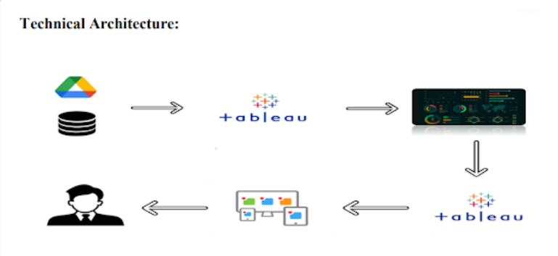

Table-1: Components & Technologies:
Component | Description | Technology
User Interface | Web interface for dashboard & story viewing | HTML, CSS, Bootstrap 5
Dashboard Integration | Embed UNESCO Dashboard | JavaScript, Tableau Embed API
Story Integration | Embed Tableau Story | Tableau Public
Dataset Storage | UNESCO Dataset 2019 stored in Tableau | Tableau Data Extract
Hosting | Website hosting | GitHub Pages / Local Hosting
Dashboard Hosting | Dashboard published online | Tableau Public Cloud

Table-2: Application Characteristics:
Characteristic | Description | Technology
Open-Source Frameworks | Frontend frameworks | HTML5, CSS3, Bootstrap
Security | Secure dashboard embedding | HTTPS
Scalable Architecture | Modular structure | Cloud-based deployment
Availability | 24/7 Dashboard access | Tableau Public
Performance | Optimized UI & loading | Bootstrap Grid

